How to get line numbers in Visual Studio

1. Open your Visual Studio Project.
2. In the top toolbar, select TOOLS> Options. You will get a dialog window titled options:

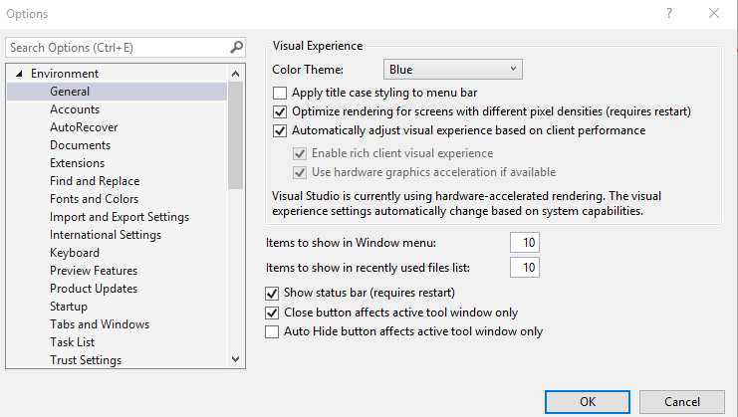

1. Close the Environment section and find Text Editor. Select C/C++:
2. 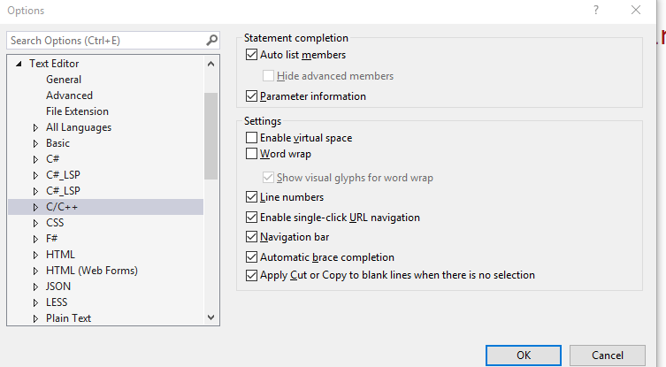
3. Click on check box in front of Line numbers.
4. Press ok. You’re good.